I. CAKE SIAM DAWN A PAWIMAWH ZUALPUI TE
Mamawh te:-
1. Oven/ Cooker/ Bel nghahchhan/ Bel chehna
2. Cake tray
3. Butter/ Parchment paper
4. Bukna (Weighing scale)
5. Fian (Spoon)
6. No tehna
7. Grinder
8. Cake chawhna tur fian (Spatula)
9. Bowl (Stainless Steel/ Plastic/ Glass)
10. Hand mixer/ Whisk
11. Apron/ Lukhum
12. Pot holder/ Oven glove

II. CAKE SIAM DAWN A KAN TIH HMASAK TUR TE
1. Cake siam dawn a hmanrua tur zawng zawng lak khawm hmasat phawt tur, ban mai theihah dah vek tur.
2. Kan ingredient hman tur, buk ngai chi ho zawng zawng buk fel hmasak phawt tur.
3. Chini lo tih dip lawk thlap tur.
4. Oven set fel thlap tur.
5. Cooker cake kan siam dawn a nih chuan, cooker, bel nghahchhan, cake tray, a chehna tur (Tong) emaw
balu/ chi kan lo dah bawk tur a ni.

III. CAKE SIAM DAWN A HRIATTUR PAWIMAWH ZUAL TE
1. Cake siamna tur hmanrua te hi a buk dik tak an ni tur a
ni.
2. Cake chawh nan hian stainless steel, plastic bowl emaw
darthlalang bawl hman a tha ber a, Alluminium hman loh tur,
amaherawh chu cake ur nan chuan aluminium mould a tha
ber thung a ni.
3. Cake chawh hian sana vir zawng a chawh tur a ni a, chawh
dan hi thlak khual chhen loh tur, uluk taka chawh that poh
leh cake a dik duh bik.
4. Cake siam nan a, chini kan hman tur hi, tih dip hmasak phawt
tur. Hetia kan tih dip hmasak hian chini chawh ral a awl bik a,
hun a heh lo bawk a ni.

5. Cake ur lain a urna oven emaw, bel emaw, cooker emaw
hawn chhen loh tur.
6. Kan cake ur a hmin hnu a, a urna atanga kan lak chhuahin,
cake tih daih hmasak phawt a tha, minute 15 vel tal nghah a
cut chauh tur a ni.
7. Thil teh reng rengin no emaw, fian emaw pawh nise a vum a
teh loh tur, a huih a teh zel tur a ni.
8. Essence/ flavour telh hian a rim a ti tui a, cake thang rim a
hliah khuha, cake a tih tui phah bawk a ni.
9. Cake mould (tray) hi tel mawm a chulh tur / parchment
paper neih loh chuan paper var phah tur, maida kan phah lo a
nih chuan tlem phul kual thet thet tur.
10. Cake ur nan oven kan hman dawnin minute 10 vel 250° C ah
pre heat hmasak ngei ngei tur a ni.
11. Kan cake a hmin leh hmin loh kan hriat duh chuan, chemte
emaw tooth pick in cake lai takah khan han chhun lut ila,
berh miah loa, alo mawm fai hlarh chuan kan cake ur kha a
hmin a lak chhuah a hun tihna a ni.
12. Cake urna oven hi in ang lo tak tak te an ni a, a hlui leh a
thar deuh te pawh a ni thei. Current load san leh san loh
a zir tein cake ur sat zawng leh a ur rei zawng a inang lo thei
a ni.

CAKE RECIPE
1. CHOCOLATE CAKE
Ingredient:
Sl.No. | Particulars | Double | Single
1. | Maida | 500 gms | 250 gms
2. | Coca powder | 100 gms | 50 gms
3. | Chini | 400 gms | 200 gms
4. | Artui | 15 nos. | 8 nos
5. | Chocolate Essence | 2 tsp | 1 tsp
6. | Vinegar | 4 tsp | 2 tsp
7. | Vegetable oil | 180 ml | 90 ml
8. | Baking powder | 2 tsp | 1 tsp
A siam dan :
- Artui kan thliar hrang ang, a pawn var leh a chhung mu
- Artui var (Egg White) leh vinegar kan mix ang, tha takin a var hlarh thleng, chocolate essance pawlh tur.
- Chini dip kan pawlh ang, a khal thleng a chawh tur.
- Artui chhung mu (Egg yolk) kha a vaiin kan telh leh ang, kan egg white chawhah khan. Tha takaa mix hnuah kan dah rih ang.
- Maida, Coca powder leh Baking powder (dry ingredients) ho khi uluk deuhin wire whisk/ wooden stick in kan mix ang.
- A hma a kan cake chawhnaah khan kan hri lut ang, a vai loin, tlem tlemin kan hri lut anga, spatulla in kan lo mix zel ang uluk deuhin a mu awm lo turin.
- Vegetable oil kan mix leh ang a, uluk takin kan chawk leh ang.
- Cake mould-ah kan chhung luhin a mawng kan sawh rual ang. 180° ah 40-60 minutes kan ur ang.
- Oven in ang lo tak tak kan hman thin avang leh current chak leh chak loh awm thei a nih avangin, bake chuung hi a reiin a rei lo thei a, chuvangin minutes 25 ah alo la hmin lo a nih pawn a minutes herh belh leh mai tura ni.

2. CHEESE CAKE
Ingredients:
- Artui - 3 nos.
- Sertui - 1 tsp.
- Chini - 1 cup
- Cheese cream/ cheese sp[read - 1 Pack
- Amul fresh/ cream/ Ajanta cream - 1 ltr.
- Maida - 1 cup (thingpui inna no)
- Paneer - Duh ang zat
A siam dan :
- No. 1 atanga No. 3 khi tha taka chawhpawlh vek tur
- No. 4 atanga No. 6 ho hi tleh a, tha taka chawhpawlh leh tur . No. 7 hi tih sawma pawlh tur
- Oven kha 150°C velin 50 minutes a ur tur, chumi hnuah 200°C in 20 minutes vel ur tawh mai tur
Cake kan ur zawhah, kan cheese cake kha fridge-ah darkar 6 vel dah bawk tur a ni

3. CARROT CAKE
Ingredients:
- Carrot - 2 Medium (tih dip tur)
- Maida - 1 cup
- Chini - 1 cup (tih dip tur)
- Artui - 2 nos.
- Baking powder - 1.5 tsp. /Baking soda - 1.5 tsp
- Chi - 1/2 spoon
- Tel - 1/2 cup
- Vanilla Essence - 1 tsp
A siam dan :
- Maida/ baking powder/ Soda leh chi kha tha taka chawhpawlh tur.
- Artui bowl-ah chawh tur chutah chuan chini dip thlak a chawh tur, Vanilla essence leh tel pawlh leh tur.
- Artuiah khan Maida pawlh leh tur, chutah carrot dip kha chhung luh a, tha taka chawhpawlh tur, zawi te te a, chawhpawlh tur.
- Baking tray tih mawm a, paper phah a, chhung leh tur. Tichuan 180°C (350°F) ah 45-55 minutes bake tur

4. PLAIN CAKE
Ingredients:
- Artui - 6 nos.
- Chini - 150 gms.
- Maida - 200 gms.
- Vanilla Essence (optional) - 1 tsp.
- Baking powder - 1 tsp.
- Butter - 200 gms.
- Milk - 1/2 cup
A siam dan :
- Maida leh baking powder hrik pawlh tur.
- Butter leh chini hneh taka chawhpawlh tur, a zang haih thlengin (Light & fluffy).
- Butter chawhpawlhah khan artui pakhat te te a pawlh tur (hneh taka chawh tur), vanilla essence pawlh leh tur.
- Maida 1/3 pawlh tur, chumi hnuah maida leh milk a chhawkin tlem te te a a zawh thleng a pawlh tur. Spatula a chawh tur.
- Oven-ah 150-180°C in darkar khat atanga darkar khat leh a chanve vel ur tur.

5. Banana Cake
Ingredients:
- Banana - 3 nos. ( a hmin tha)
- Maida - 1 cup
- Chini - 1 cup (tih dip tur)
- Artui - 2 nos.
- Baking powder - 1 tsp. / Baking soda 1 tsp.
- Butter - 1/2 cup (tih tui tur)
- Vanilla Essence - 1 tsp.
A siam dan :
- Artui kha tha taka chawh tur, chutah chuan vanilla essence leh chini dip kha pawlh a chawh leh tur, butter tih tui kha pawlh leh tur.
- Balhla hmin kha bowl-ah fork in tih kawi/sawm tur.
- Artui mix leh Balhla kha chawhpawlh leh tur a ni a, tha taka chawhpawlh tur. Chuti chuan maida leh baking powder/ Soda pawlh leh tur .
- Baking tray tih mawmah khan leih luh a, 180°C ah minutes 45 a ur tur a ni.

6. SPONGE CAKE
Ingredients:
- Artui - 8 nos.
- Chini - 250 gms.
- Maida - 250 gms.
- Vanilla Essence - 1 tsp
A siam dan :
- Artui tha taka mix tur, Vanilla essence pawlh leh tur.
- Artuiah khan chini thlak a tha taka chawhpawlh tur.
- Artui mix-ah khan maida pawlh leh tur.
- Cake tray tih mawm a, paper phah a kan cake batter kha chhun luh tur. Oven-ah 220°C in 30 minutes ur tur a ni.
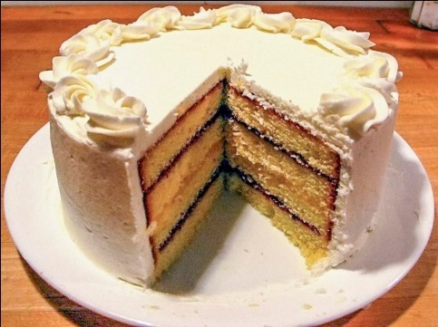

Published by:
Krishi Vigyan Kendra Kolasib, Kolasib District,
Department of Agriculture, Govt. of Mizoram

For further details and information, contact:
Dr. Michelle C. Lallawmkimi
The Senior Scientist & Head
Krishi Vigyan Kendra
email@kvkkolasib@gmail.com
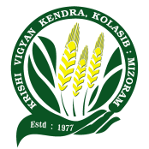
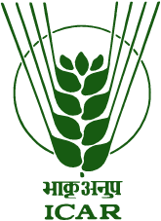

TUI TAKA CAKE UR DAN
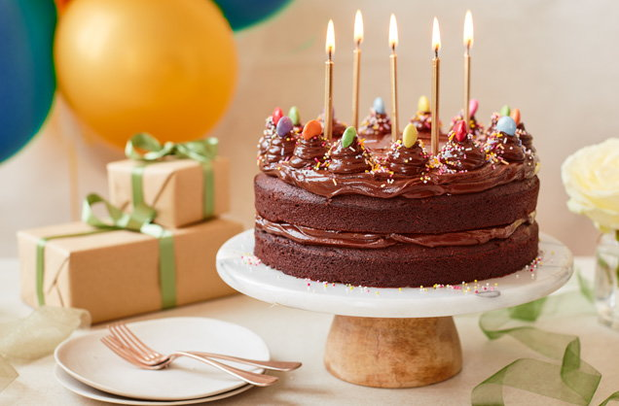

Prepared by:
Lalrinpuii Sailo
Programme Assistant (Home Science)
KVK Kolasib, Kolasib District
Mizoram

