Sweet siam dawna mamawh zualpui te:
- Bel mawng chhah (heavy base cooking pot)
- Bel vawn chhan sei nei ( sauce pan)
- Fian sei ( ladle/ spatula)
- Bukna (weighing scale)
- Bowl lian(glass/ stainless steel)
- Thirfiante (spoon)
- Chemte (knife)
- Cutting board
- Container/ stand up ziplock
- Grinder (chini tih dip nan)
- Bel vawn chhan (pot holder)
- Apron/ Lukhum
- Chhihri (Strainer)
Sweet siam dawna hriattur pawimawh zual te:
- Sweet siam ni hi kan thlang uluk tur a ni. Hralh chhuah leh tur kan siam dawn a nih phei chuan
Khaw that ni kan thlang thin tur a ni.
- Bel mawng chhah tha tak kan hmang tur a ni. Kan sweet siam a dik theih nan leh a ut/ kan loh nan.
- Kan sweet siamna tur hmanrua kha thar tha tak kan lei thin tur a ni.
- Sweet kan siam hian a dah thatna tur kan ngaihtuah uluk a ngai hle a, container emaw a pack-na sarang kha boruak lut lo tur a ni. A fai thain a ro tha hle tur a ni.
- Chocolate i siam chuan alluminium foil-in tuam thin ang che.
- Sweet chi hnih thum vel i siam khan dah pawlh nuaih loh tur. A hrang theuh a pack tur.
- Sweet kan siam dawnin apron, lukhum, bel vawn chhan kan hmang zel tur a ni.
- Thil teh reng rengin fian emaw no emaw pawh nise a vuma teh loh tur a ni, a huih zela teh tur a ni.
Sweet Recipe
1. Maipawl sweet
Ingredients :
- Maipawl - 1 kg
- Chini - no 3 (750 grm)
- Chinai - 1 tbs emaw Vinegar - no 1
- Rose water/ Nimbu tui - 2 tbs. (optional)
- Icing sugar/ Chini dip - no 1
A siam dan:
- Maipawl chu a kawr leh a chhung mu kheh a paihfai vek tur a ni, a sei zawngin chan phawk phawk tur.
- Maipawl chu fork-in chhun chik kual vek tur.
- Maipawl chhun chik chu duh ang tiata chan tur.
- Chinai kha bowl lianah tui nen chawhsawm veka darkar 12 chhung vel maipawl kha chiah tur a ni (hmanhmawh thila kan siam dawn a nih chuan chinai a chiah lovin vinegar-in 20 minutes vel chiah tur a ni).
- Maipawl kan chiah chu tui thianghlimin fai takin vawi 3 vawi 4 vel kan sil tur a ni.
- Tui nen maipawl kha chhum so bawh bawrh tur, chumi hnuah a tui paih a dah thli thlawr leh tur.
- Bel mawng chhahah tui tlem nen maipawl leh chini chhuan pawlh tur a ni.
- Chini tui a lo kanga a lo hnang thlarh hunah suan chhuah a insi lovin tray-ah dah ro tur a ni.
- Maipawl chu a ro hnuah icing sugar/ chini dipin phul kual tur a ni.
- Bur ro leh thianghlimah duh hun huna ei theih turin dah that tawh mai tur a ni.

2. Sertawk sweet
Ingredients :
- Sertawk - pum 2
- Chini - no 3 ( 750 gram)
- Icing sugar/ Chini dip - no 1
A siam dan :
- Sertawk pum chana a kawr lak hran a, a kawr pawn ber chan thlak tur a ni.
- Sertawk kawr chhung zawk a dup lai kha duh ang tiatin chan nawi tur a ni.
- Sertawk kawr dup chan nawi chu tuiah fai takin sil tur a ni. Tui a chhum so bawrh bawrh hnuah tui vawtin tleuh a fu taka sawr tur a ni.
- Bel mawng chhah chhuan a tui tlem nen serkawr dup sawr fu kha dah luh tur a ni.
- Chini pawlh a chhuan so bawrh bawrh tur.
- Ser leh chini chu a lo hang hlarh hnuah suan chhuaha tray-ah insi lovin dah ro tur a ni.
- A lo ro hnuah icing sugar/ chini dip phul a, bur fai taka daha duh hun hunah ei theih mai a ni.
3. Turkish delight
Ingredients :
- Chini - no 1 (200 grams)
- Nimbu tui - 2 tsp
- Tui - 1/4 cup (50 ml)
A chung ami ho zawng hi gas-ah a khang thlengin chhuan tur (10 minutes)
- Cornflour - 1/4 cup (4 tbs)
- Tuin - no 1 (200 ml)
- Nimbu tui - 5 ml
- Baking powder - 1/4 tsp
A chung ami ho zawng hi gas-ah a lo khal thlengin chhuan tur a ni.
A siam dan:
- Chini tui leh cornflour chhuan sa ho kha kan pawlh tur a ni.
- Gas sim a a lo khal fim deuh thlengin chawh reng tur a ni a, a tul huna herh san zeuh theih a ni.
- A rawng tih mawi nan food colour duh ang rawng pawlh bawk tur a ni.
- Mould i chhun chhuahna turah khan tel chulh a, chhun luh mai tur a ni. A daih hunah darkar 2 vel fridge-ah i dah anga i duh ang size-in cut la chini dip/ cornflour/ icing sugar phula ei theih mai a ni e.
4. Chocolate sweet
Ingredients :
- Coconut oil - 2/3 cup
- Icing sugar/ chini dip - 1 cup
- Bawnghnute dip - 1/2 cup
- Cocoa powder - 1/2 cup
A siam dan:
- Sauce pan-ah tui chhuang la, a chungah bowl sa ngam tur chi chhuang ang che.
- Dry ingredients (chini/ bawnghnute dip/ cocoa powder) te hi chawhpawlh vek tur.
- Bowl chhuanah khan coconut oil leih luha chutah chuan dry ingredients ho kha fianin suah luh zeuh zeuha chawh pah reng tur. A vaia kan chawhpawlh hnuah a lo khal deuh hnuaha suan thlak tur.
- Mould/ thleng kan chhun chhuahna tur kha kan ti mawm a nih loh chuan butter paper phah tur (chocolate mould kan hman loh chhuan).
- Kan chocolate chu kan chhung chhuak anga duh leh nuts kan pawlh tel thei a ni.
- Dah daih a fridge-ah darkar 4- 6 vel dah hnuah ei theih mai a ni.
5. Rasagulla
Ingredients :
- Bawnghnute - 1 ltr
- Chini - 1 kg
- Nimb tui - 1 tbs
A siam dan :
- Bawgnhnute tak tha deuh kha belah chhuan so bawrh bawrh tur a ni.
- Bawnghnute soah khan nimbu tui kha pawlh ang che, chu chuan bawnghnute kha a lo ti chhia anga a tak leh a tui a lo hrang hlak ang. A tak zawng kha la hrang la puan pan fai takah fun la tui thianghlimin tleuh ang che.
- Tawn khawm la, sawr fu la che lovin darkar 1-3 vel khai kang ang che.
- Che lova kan khai hnuah lakthlak a, dawhkan fai takah hmeh khawm a hrual mum leh tur a ni.
- A let hniha a rawn len dawn avangin tereuh te tein kan hrual mum tur a ni.
- Bel mawng chhahah chini tui kan chhuang so anga, elaichi duh leh kan pawlh leh ang, chumi hnuah rasagulla kan hlum ho kha kan thlak ang. Chumi hnuah chhin phui a so tir cherh cherh tur a ni, a khat tawkin a chhin hawna chawh zeuh zeuh tur.
- Rasagulla chu a lo len thur hnuah suan daih a, bur fai takah dah a duh hun huna ei theih mai a ni.

Prepared by:
Lalrinpuii Sailo
Programme Assistant (Home Science)
and
Dr. Michelle C. Lallawmkimi
Senior Scientist & Head
For further details and information, contact:
Dr. Michelle C. Lallawmkimi
Senior Scientist & Head
Krishi Vigyan Kendra
email@kvkkolasib@gmail.com

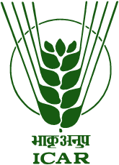
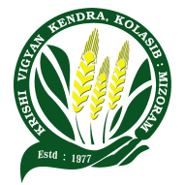

SWEET CHI HRANG HRANG TUI TAKA SIAM DAN

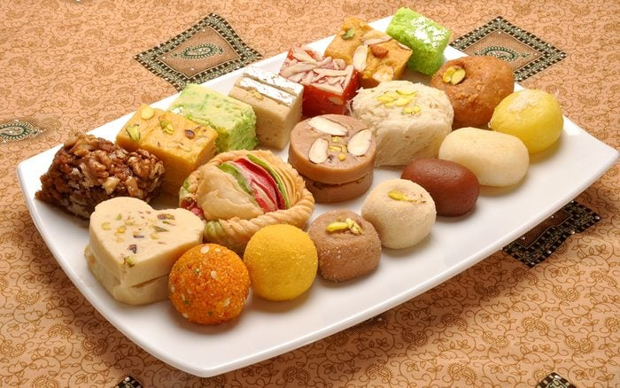

Published by:
Krishi Vigyan Kendra Kolasib, Kolasib District,
Department of Agriculture, Govt. of Mizoram

