I. PICKLE SIAM DAWN A PAWIMAWH ZUALPUI TE
Mamawh te:-
1. Thir bel (deep fry pan)
2. Bukna (Weighing scale)
3. Fianpui/ Fian sei (ladle/ spatula)
4. Chemte, bakcheh
5. Bowl lian (stainless steel/ plastic/ glass)
6. Grinder/ um leh suk/ rawt thleng lian
7. Thir fian (Table spoon), cutting board
8. Container (Pickle dahna bur emaw a pack na tur)
9. Apron/ Lukhum
10. Bel vawnchhan (pot holder)
11. Tel, Masala, aieng, chi, vinegar, aginomoto, chilli powder
purunsen, sawhthing

II. PICKLE SIAM DAWN A KAN TIH HMASAK TUR TE
1. Pickle siam dawnin a hmanrua tur zawng zawng lak khawm
hmasak vek phawt a, ban mai theihah dah lawk vek tur.
2. Kan pickle siam tur (ingredients) buk ngai chi ho zawng
zawng buk fel hmasak phawt tur.
3. Purunsen, purunvar, sawhthing te lo tih fai a, lo grind/ den
sawm lawk tur.
4. Masala, aieng, chilli powder etc. kha kan hma tawk tur lo
dah hran tur.

III. PICKLE SIAM DAWN A HRIATTUR PAWIMAWH ZUAL TE

1. Thir bel kan hman tur kha pickle kan siam zat tur a zirin a
lianin a te tur a ni, khat lutukin thir bel kan hmang tur a ni lo.
2. Thil teh reng rengin no emaw, fia emaw pawh nise a vuma
teh loh tur a ni a, a huih zela telh tur a ni.
3. Keimahni kan him zawk nan Pickle chawh nan fian a fawng
sei kher hman tur a ni.
4. Pickle an siam tur a kha chhum hmin phawt ngai chi a nih
chuan tha taka thlit hul hmasak phawt tur, a sawr theih ci
phei chu sawr fu that vek tur.
5. Pickle kan siam tura kha chhum ngai lo chi chu, fai taka sil
phawt a tha taka tlit hul/ dah hul phawt tur.
6. Pickle kan siam hmain, a rim te a lo nain, in tih palh theih a
nih avangin, apron, lukhum, bel vawn chhan te hman zel tur
a ni.
7. Pickle dah that nana kan hman bur (container) kha fai tak leh
hul tha tak a ni tur a ni. Pickle pack-na (sarang) a kan pack
dawn a nih pawhin fel fai takin kan pack tur a ni.
8. Bur (container) a pickle kan dah hian, rei tak (chemical
hmang lo) dah kan duh dawn chuan, pickle kha telin a chim
thlap tur a ni.
9. Rei tak, kum hnih thum vel dah kan duh chuan Citric acid
emaw Sodium Benzoate a pawlh tur zat dik tak pawlhin dah
tur a ni.
PICKLE RECIPE
1. BAWNGSA PICKLE
Ingredients:
- Bawngsa ti - 1Kg.
- Purunvar - 100 gms.
- Purunsen - Pum - 4 (medium size)
- Ginger - 100 gms.
- Tel - 500 gms.
- Hmarcha hmui - Duh ang tawk telh mai tur.
- Chi/ aginomoto - Duh ang zat.
- Aieng - 2 tsp.
- Vinegar - 4 tbsp.
- Pickle masala or garam masala or Jeera etc. - 2 tsp. (masala hi duh ang ang)
A siam dan :
- Bawngsa hi chan a, tui tlem teah (cooker in) chhum phawt tu (chhum kher loh pawn chan a kan phawt tur).
- Bawngsa chhum chu, duh anga chan nawi leh tur. Tel-ah fry leh phawt a, a ro a siam i duh chuan/ duh loh chuan fry hran leh kher a ngai lo
- Tel kha deep fry pan (thir kan bel) lianah tih hmui/ sat tur.
- Tel-ah chuan purun var/sen/ginger mix kha thlak a, a lo sen deuh thlengin, chutah chuan i sa fry sa emaw i sa chhum cha nawi kha thlak la, mix that tur.
- Aieng/ masala/ chi/ aginomoto/ hmarcha pawlh leh tur.
- Tha taka chawh a, minute 5 hnuah vinegar pawlh la, mix that tur. Suan dai la, bur faiah thin tur. (gas flame hi medium-ah dah tur)

2. Chilli oil
Ingredients:
- Hmarchapuisen ro - 1Kg.
- Tel -1 ltr.
- Chhawhchhi var - No khat
- Purun var - 100 gms.
- Sawhthing - 100gms.
- Chi - Duhang tawk
- Aginomoto - Duh leh duh loh
- Bay leaves/ karan phool/ thakthing - Duh leh duh loh
A siam dan:
- Chhawhchhi kan hmui tur
- Purun sen, ginger, kan chan nawi ang.
- Tel kan chhuang hmui ang, mei kan herg hniam ang, Bay leaves/ karan phool/ thakthing thlaka lak chhuah leh tur.
- Purun var, sawhthing kanchan nawi kha kan thlak ang, a lo ut uk tan hnuah.
- Hmarcha ro dip kan thlak ang, chi leh aginomoto kan pawlh ang a, kan chawk ang.
- Minutes 3 hnu velah chhawhchhi kan pawlhh ang a, kan, suan dai anga bur-ah (container) kan dah ang.

3. Nutrela Pickle
Ingredients:
- Nutrela - 1kg
- Tel - 600 ml.
- Purunsen - 6 medium
- Purunvar - 100 gms.
- Sawhthing - 100 gms.
- Chi - A al tawk
- Chilli powder - Mahni duh zat
- Aieng - 1 tsp.
- Pickle masala emo duh duh masala hman mai tur(garam/jeera etc)
- Vinegar - 4 tbs.
A siam dan
- Nutrela kha chiah hmasak tur(tui vawt ah chiah mai tur).
- Chumi chhungin purunsen/var/ginger lo grind a,lo dah hran tur.
- Nutrela chiah kha fu taka sawr vek tur,chu chu chan sin leh vek tur.
- Thirbel lian ah tel kha leih luh vek a,chhuan tur,tel alo sat hunah gas herh hniam la, Nutrela chan nawi kha a ro uk deuh thap thlenga kan tur.
- Thirbel hran chhuang la, Nutrela kan na tel kha leih lut rawh,tah chuan purun mix kha thlak tur tur.
- Minute 3 hnu velah masala/aieng/chilli powder/agino/chi,tih vel kha pawlh tur.
- Uluk takin chawhpawlh la minutes 5 vel i chhuan hnu ah a thak tha deuh i duh chuan hmarchate hmui emo hmarchapui sen ro grind i duh tawk pawlh la, vinegar tha takin mix ang che,gas i off hma in vinegar pawlh la,suan la dah dai la,bur faiah dah tawh mai tur.

4. HMARCHAPUI PICKLE:
- Hmarchapui - 1kg
- Tel - 500 ml.
- Purunsen - 4 medium
- Purunvar - 100 gms.
- Sawhthing - 100 gms.
- Chi - A al tawk
- Chilli powder - Mahni duh zat
- Aieng - 1 tsp.
- Chhawhchhi - No 1
- Pickle masala emo duh duh masala hman mai tur(garam/ jeera etc)
- Vinegar - 2-4 tbs.
A siam dan
- Hmarchapui chu silfai a thlit hul hnuah duh ang a chan tur.
- Chhawhchhi chu kang hmui la, dengdip bawk rawh.
- Purun var, purun sen, sawhthing chu rawt dip ang che.
- Tel chhuang hmui la, purun var, purun sen, sawhthing hersawm chu thlak la, a lo sen thep hunah aieng, pickle masala, chu telh la, tichuan hmarchapui chu in thlak dawn nia, chi leh ajinomoto pawlh leh ang che.
- Hmarchapui chu a lo zawr deuh hnuah chhawhchhi chu thlak la, mei hniamte ah ur cherh cherh ang che. Suan dawnah vinegar pawlh ang che.
- Heti hian a ei theih nghal mai a, bur phui leh hul takah dah la, reitak chhung a awm thei a ni.
5. KAIKUANG PICKLE:
- Kaikuang ro - 1/2 kg.
- Tel - 500 ml.
- Purunsen - 4 medium
- Purunvar - 100 gms.
- Sawhthing - 100 gms.
- Chi - A al tawk
- Chilli powder - Mahni duh zat
- Aieng - 2 tsp..
- Tengtere tui - 200 ml.
- Pickle masala emo duh duh masala hman mai tur(garam/jeera etc)

A siam dan
- Tengtere hmin kha tui 200 ml. ah chiah hnuah a tak zawng paih a, a tui dah hran tur.
- Purun var, purun sen, sawhthing chu rawt dip ang che.
- Kaikuang kha tel hmuiah kan ro tur.
- Purun var, purun sen, sawhthing rawt dip hi kaikuang kan roah thlak leh tur.
- Aieng, pickle masala, chilli powder, chi leh ajinomoto pawlh leh ang che.
- Chumi hnuah tengtere tui telh leh atha taka chawh pawlh leh tur.
- Heti hian a ei theih nghal mai a, bur phui leh hul takah dah la, reitak chhung a awm thei a ni.

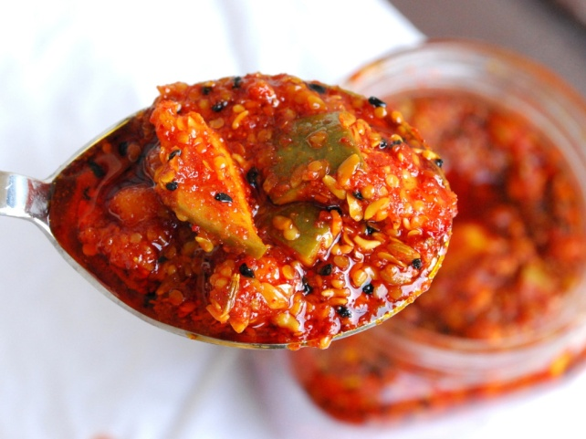

Published by:
Krishi Vigyan Kendra Kolasib, Kolasib District,
Department of Agriculture, Govt. of Mizoram

For further details and information, contact:
Dr. Michelle C. Lallawmkimi
The Senior Scientist & Head
Krishi Vigyan Kendra
email@kvkkolasib@gmail.com
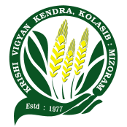
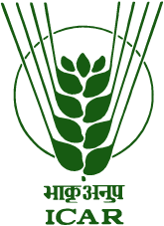

TUI TAKA PICKLE CHI HRANG HRANG SIAM DAN

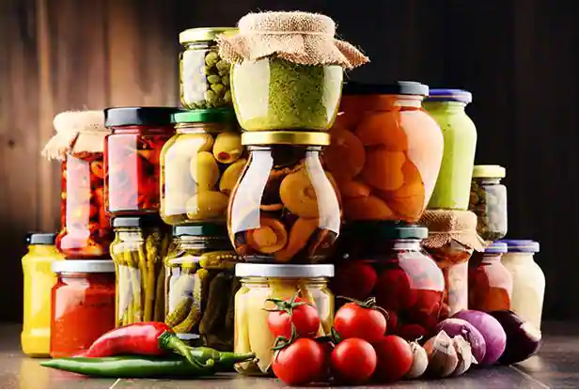

Prepared by:
Lalrinpuii Sailo
Programme Assistant (Home Science)
KVK Kolasib, Kolasib District
Mizoram

