Kan ei leh inah hian Sa (Meat) hian hmun pawimawh tak a chang a, kan taksain a mamawh chakna chi hrang hrang (Essential Nutrients) heng protein, vitamins, minerals leh chaw tha dang kan hmuhna a ni.
Sa kan lei dawn a kan hriattur pawimawh zualte chu:-
- A lan dan en ngun tur (Examine the texture)
- A rawng en ngun tur (Check the colour)
- A rim a dike em (Notice the smell)
- Sa leiin a hran hlaka khai tur (Carry separately)

Meat Ball Ingredients:
  - Arsa/ Bawngsa/ Vawksa – ½ Kg.
  - Bread Crumbs – 60 gms (1/2 cup)
  - Chi – A al tawk tur
  - Masala – 1 tsp
  - Black papper – 1tsp
  - Purun var den sawm – 1 tbsp
  - Alu chum hmin den sawm – pim 2
  - Artui – 1 no
  - Dhania/ pardi chan nawi - 2 tbsp

A siam dan :
- Sa her dip/ sawm tur.
- Sa her sawm leh pawlh tur ziah zawng zawng chawhpawlh vek tur.
- Sa chawhppawlh chu kutin duh ang tiat a hrual mum tur a ni.
- Thir kan belah tel 100 ml in, mei hniam teah ur hmin sen thep tur a ni.
- Meat ball chu tihian a ei theih mai a, a duh tan chawhmeh dang nen a kan pawlh theih bawk.

Meat Nuggets Ingredients:
  - Arsa/ Bawngsa/ Vawksa (A ti lai) – ½ Kg
  - Nutrella – ½ kg
  - Cheese – 200gms (optional)
  - Purun sen/ var/ sawhthing miz – 2 tbsp
  - Chi – A al tawk tur
  - Masala – 1 tbsp
  - Artui – 2 nos.
  - Cornflour – 80 gms (1/2 cup)

A siam dan
- Sa leh Nutrella a hran ve vein her sawm tur.
- Nutrella leh sa her sawm-ah purun vur/ sen/ sawhthing, chi masala, artui te chawhpawlh vek tur.
- Sa chawhpawlh chu duh ang shape-in hlawm tur a ni, cheese pawlh duh tan chuan sa hlawmkarah cheese phum tur a ni.
- Tel (200 ml) ah mei hniamah ur hmin tur a ni.
- Dah tha duh tan chuan container-ah frozen mai tur a ni.

Meat patties Ingredients:
  - Arsa/ Bawngsa/ Vawksa (a ti lai) – ½ Kg.
  - Purun sen/ var/ sawhthing mix – 1 tbsp
  - Artui – 1 nos
  - Bread crumbs – 60 gms
  - Chi - A al tawk tur
  - Purub chawr chan nawi - 2 tbsp

A siam dan :
- Sa her dip/ sawm tur.
- Sa her sawmah pawlh tur dang zawng khi chawhpawlh vek tur a ni.
- Sa hlawm hi bial deuhin a hran te tein dah tur.
- Tel (100 ml) ah mei hniam tein ur hmin mai tur a ni.

Kolasib Fried Chicken (KFC) Ingredients:
  - Arsa– 1 Kg.
  - Dhoi – 1 cup
  - Masala – 2 tsp
  - Purun sen/ var/ sawhthing miz – 2 tbsp
  - Chi – A al tawk tur
  - Maida – ½ Kg
  - Tel – 500 ml

A siam dan :
- Arsa sil fai a duh ang tiat a chan tur
- Dhoi, purun var/ sen/ sawhthing mix, masala leh chi khan arsa chiah tur a ni, a rei lo berah darker 1 tal chiah tur a ni.
- Arsa chiah kha maida-ah tal kual ceka, tui thianghlimah chiah tur a ni a, hei hi cawihnih vel tih nawn tur a ni.
- Tel saah arsa kha a mal te tein thlak a, kan hmin tur a ni.

Chilli chicken pork Ingredients:
  - Sa ti -– ½ Kg.
  - Zikhlum– ½ Kg or Capcicum - 250 gms
  - Maida - 100 gms
  - Artui - 1 nos
  - Masala - 1 tsp
  - Black papper - 1 tsp
  - Purun sen – 250 gms
  - Hmarchapui – 100 gms
  - Chilli powder – 2 tbsp
  - Chi – A al tawk tur
  - Cornflour – 40 gms
  - Soyabean sauce – 2 tbsp
  - Oyster/ tomato sauce – 2 tbsp

A siam dan :
  - Sa te reuh te tea chan tur, Maida, artui, cprnf;our, black papper, masala, chi a hmeh pawlh tur, tel 400 ml-ah sa hi kan sen deuh thep tur.
  - Sa kha a lo hmin sen deuh thep hnuah zikhlum/ capcicum leh purun sen thlak tur a ni. (Zikhlum/ capcicum leh purun sen hi lian deuh hlek a chan phawk phawk tur)
  - Hmarchapui phel phawk kha thlak leh tur.
  - Chilli powder, chi, soyabean/ oyster sawuce pawlh tur.
  - Tha taka chawhpawlh hnuah minutes 2 vel chhuan hnuah cornflour kha tui tlem teah chawh hnuah sa kanah thlaka, a so bawrh bawrh hnuah suan a ei theih mai a ni.
  - Vegetables kan thlak kha hmin lutuk lo, hring nghalh tur a ni.

Arsa/ Bawngsa pickle Ingredients:
  - Sa ti -– 1 Kg.
  - Purun sen/ sawhthing mix – 4 tbsp
  - Tel – 500 ml
  - Chilli powder/ hmarchapui – 2-4 tbsp
  - Chi – A al tawk tur
  - Aieng – 2 tbsp
  - Masala – 2 tbsp
  - Vinegar – 4 tbsp

A siam dan :
  - Sa silfai a chant et tur a ni.
  - Sa chan tawh hnu chu telah kan hmin tur, a uk deuh thak thlen a kan tur.
  - Sa kan hmin chu duh ang a nawi a pawh/ chan nawi tur a ni
  - Tel a hranin chhuan leh a, purun sen/ var/ sawhthing mix thlak tur, chumi hnuah, masala, aieng, chi thlak leh tur.
  - Ngun taka chawhpawlh hnuah sa chan nawi kha thlak tur, minutes 3 hnuah chilli powder/ hmarcha ro pawlh leh tur a ni.
  - Ngun taka chawh hnuah vinegar tha taka pawlh a, suan dai a, bur thianghlim taka dah tawh mai tur a ni.
Note: Sa hi duh chuan cooker-ah chhum hmin hmasak a, pickle nem deuh a siam thei tho a ni.

Arsa Roast (Simple roasted Chicken)

Ingredients:
  - Arsa-– Pum 1 (2 kg vel).
(A puma duh loh chuan lian pui puia chan tur)
  - Ghee – 400 gms
(Dalda/ butter etc.)

A siam dan :
  - Arsa kha silfai la, a sa kha chemtein zai kak zeuh zeuh la, chemte hmawr zumin chhun zeuh zeuh bawk ang che.
  - Bel mawng chhah emaw, cooker ar pum leng tur kha chhuang sa la ghee thlak ang che.
  - Ghee kha a sat hmain arsa kha dah lut ang che.
  - Ar silna tui leh ama tui pai te a lo ral hnuah a khat tawkin chawh leh zeuh zeuh tur a ni.
  - Minutes 40 hnu velah ar pum kha a lo ut sen thep hnuah suan a ei theih mai a ni.

Prepared by:
Lalrinpuii Sailo
Programme Assistant (Home Science)
and
Dr. Michelle C. Lallawmkimi
Senior Scientist & Head
For further details and information, contact:
Dr. Michelle C. Lallawmkimi
Senior Scientist & Head
Krishi Vigyan Kendra
email@kvkkolasib@gmail.com

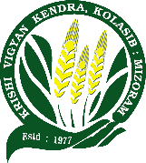
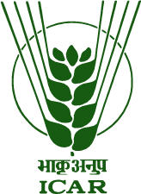

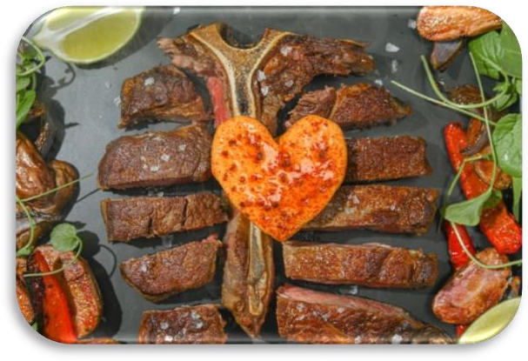
SA SIAM DAN HRANG HRANG

Published by:

Krishi Vigyan Kendra Kolasib, Kolasib District,

Department of Agriculture, Govt. of Mizoram

