- NEEMASTRA

Mamawh te: 200 litre tui, 2 kg bawng ek, 10 litre bawng zun, 10 kg neem hnah rawt sawm.
A siam dan:
- Bel lian deuh tak ah a chung a mamawh kan tar lan khi a in dawt te te in kan dah lut ang.
- Sana vir zawng in kan chawk a nga ti chuan buara in kan khuh ang. Ti hian darkar 48 chhung kan up leh a nga, nitin vawi 2 kan chawk ang. A chawh nan hian mau/ thing hmang thin tur .
- Kan dah na hmun hi nisa leh ruah in a chhun in a em pha tur a ni lo.
- Darkar 48 hnu ah chuan kan hmang thei tawh a, hei hi thla 6 chhung a dahtha thei.
- kan hmang dawn in kan thlifim leh ang a, tui nen a chawhpawlh lo in a hlang hian kan thlai/ thei kung ah hmang tur a ni.
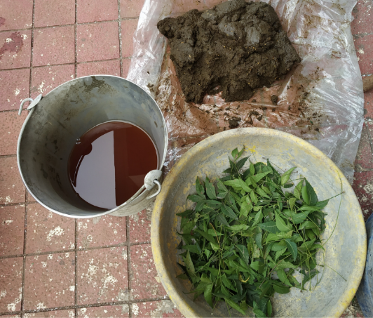
Kumthu, katnalh, thlangdar, pangang te chi, hrik var thla nei heng ho ven nan hian atangkai em em bawk a ni

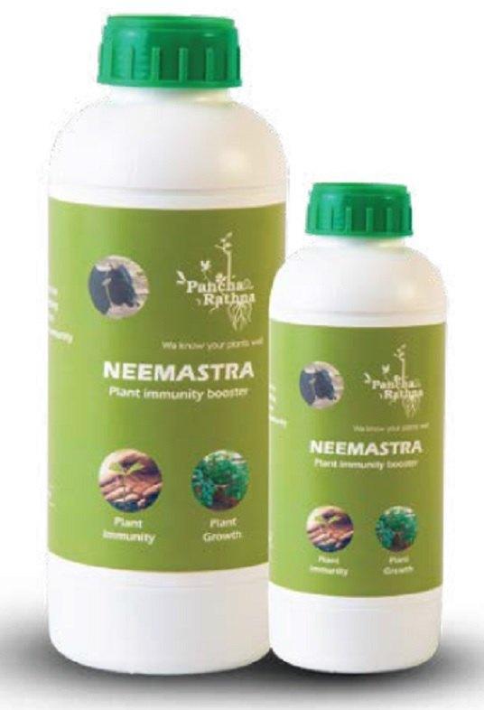

Published by:
Krishi Vigyan Kendra Kolasib, Kolasib District,
Department of Agriculture, Govt. of Mizoram

For further details and information, contact:
Dr. Michelle C. Lallawmkimi
The Senior Scientist & Head
Krishi Vigyan Kendra
email@kvkkolasib@gmail.com

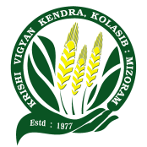
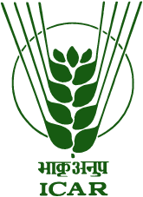

Natural Farming hnuaia thlai ven dan

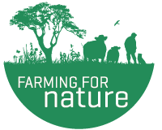

Prepared by:
Mr. Zohlunpuia
Subject Matter Specialist (Agronomy)
KVK Kolasib, Kolasib District
Mizoram

- BEEJAMRIT/SEED NECTAR: He thil hi thlai chi leh a kung phun chi te hmuar natna lak ata an him theih nan an hmang deuh ber
THIL MAMAWH TE:
Bawng ek 5 kg, Bawng zun 5 litre , Chinai thi 50 g, Huan lei 1kg, tui 20 litre
A siam dan:
- Bawngek kg 5 chu puan ah dah in tuam phui tur. Tui 20 litre ah chuan bawngek tuam phu chu darkar 12 chhung kan khai ang.
- Tui 1 litre kan la leh ang a, tah chuan chinai thi chu kan dah lut a nga, hei hi khawih che lo in zan khua a dah ang.
- A tuk zing ah bawngek kan tuam phu tui a kan khai kha kan sawr ang, hetah hian bawng ek a thlai tan a chaw tha thi reng kha a rawn chhuak dawn a ni. Hei hi tui nen tha tak in kan chawhpawlh ang.
- Huan lei 1 kg vel kha step 3 na ah khian kan pawlh a nga, tha deuh in kan chawhpawlh leh ang.
- Bawng zun 5 litres leh chinai thi khi step 4 na ah khian kan pawlh leh anga tha tak in kan chawhpawlh leh ang.
A hman dan tur:
Thlai chi ah kan leih anga chuan kan kut in tha tak in kan chawhpawlh hnu ah kan dah ro leh ang. Ti chuan kan thlai chi chu kan lo hmang thei tawh dawn a ni. Be lam thlai ah chuan kan chiah huh zuai hnu ah kan dah ro leh ang

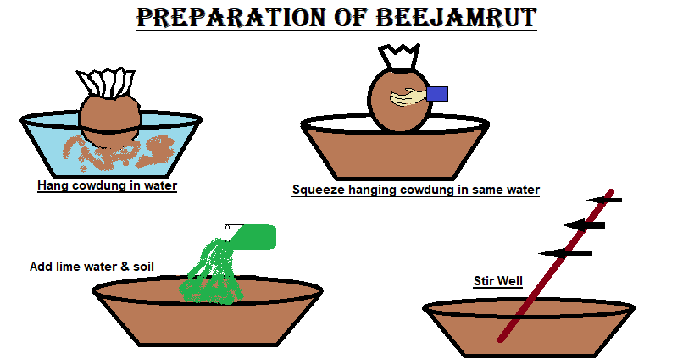
- AGNIASTRA
Pangang leh rannung a dawt a dawt chi (aphids, scale insect, mealy bug, white fly) veng nan hman thin a ni
Mamawh te:
Bawng zun 20 litre, Neem hnah rawt sawm 2 kg, vaihlo 500 gm, hmarcha hring 500 gm, purun var rawt sawm 250 gm leh aieng dip 200 gm
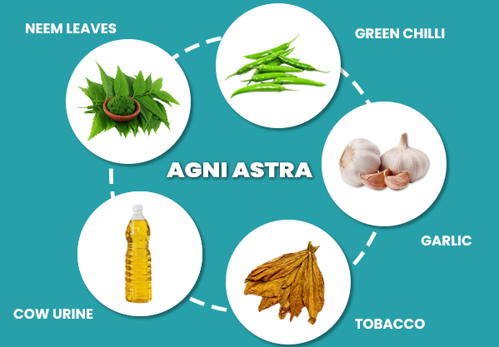

A siam dan:
- A Bel ah bawng zung kan dah lut hmasa ber ang nga chumi zawh ah kan mamawh dang ho khi kan dah leh nghal vek ang.
- Sana vir zawng in kan chawk a nga, ti chuan kan chhin a nga, mei sa ah phuan a rawn in siam hma chu kan chhuang ang.
- Phuan a insiam hnu chuan kan suan a nga, hmun hlim ah kan ni sa in a chhun phak loh na tur ah darkar 48 chhung kan dah ang. Hetih chhung hian kan thil siam chu nikhat ah vawi 2 kan chawk ang.
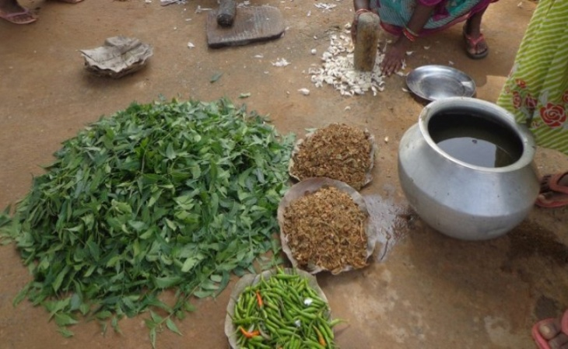
- Darkar 48 hnu ah chuan vai puan nem (Muslin cloth) hmang in kan thlifim leh ang a, ti hian thla 3 chhung chu a dahthat thei tawh dawn a ni.

A hman dan tur:
Agniastra 6-8 litres hi tui 200 litres nen chawhpawlh in kan huan thlai ah kan kap tawh ang.
Chawhpawlh dan tur hrang hrang
100 litres tui+ 3 litres agniastra
15 litres tui+ 500 litres agniastra
10 litres tui+ 300 litres agniastra

